**ITCS 2214-002 Program 3.0 – Graph Traversal Spring 2016**

**Due Thursday May 5th, 2016 at 11:55PM**

*This assignment is the first and only portion of the Graph project for this course. The primary goal is to use the IMDB actor/movie dataset and graph to compute the ‘Bacon Number’ between any two actors.*

**Overview**

The primary goals of this program are as follows:

1. Understand the Bridges Graph representation
2. Implement the pseudocode for the shortest path algorithm

You need to go through the driver and understand the provided code, then implement the baconNumber method. If you need any more tips on how to set node properties or utilize the graph representation, refer back to the GraphLab Skeleton code on Moodle.

**Tasks**

**Copy** the graphProject package from Moodle. This contains the most recent JAR file (in case you haven’t updated yours), all the relevant source files, and the imdb data file. Make sure you store the data file somewhere your IDE can easily find it. For Eclipse, this is under the project’s root directory.

**Documentation** for Bridges classes can be found at the following link:

http://bridgesuncc.github.io/doc/java-api/current/

**Driver:**

- Familiarize yourself with the code to set up the graph and read from the data file

- Next, work through the pseudocode in the baconNumber method line by line

- You will need to be comfortable with the *put* and *get* HashMap methods; the mark, dist, and parent HashMaps use the vertex name (String) as the key

**Deliverables –**

The original Bridges graph your program should generate will be something like this: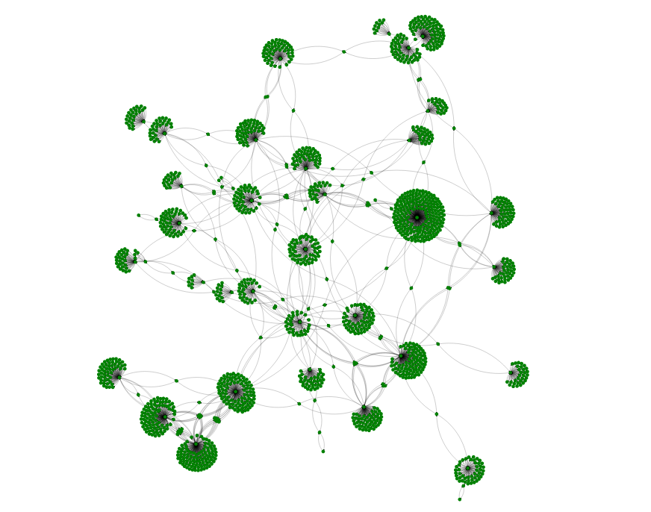

**Scoring Rubric**

**Driver:** 45 points

* Up to 5 points for appropriate documentation and comments
* Up to 40 points for correctly implementing the algorithm to compute the bacon number

**Visualization:** 15 points

* Up to 5 points for visualizing all the vertices the graph visits
* Up to 10 points for visualizing the path between any start/end vertices

**Total points available: 60**

**This will be graded as a programming assignment**

*Late programs will lose 10% of the available points per day.*